Latihan PBO Pertemuan 10
Latihan 1 Border Layout
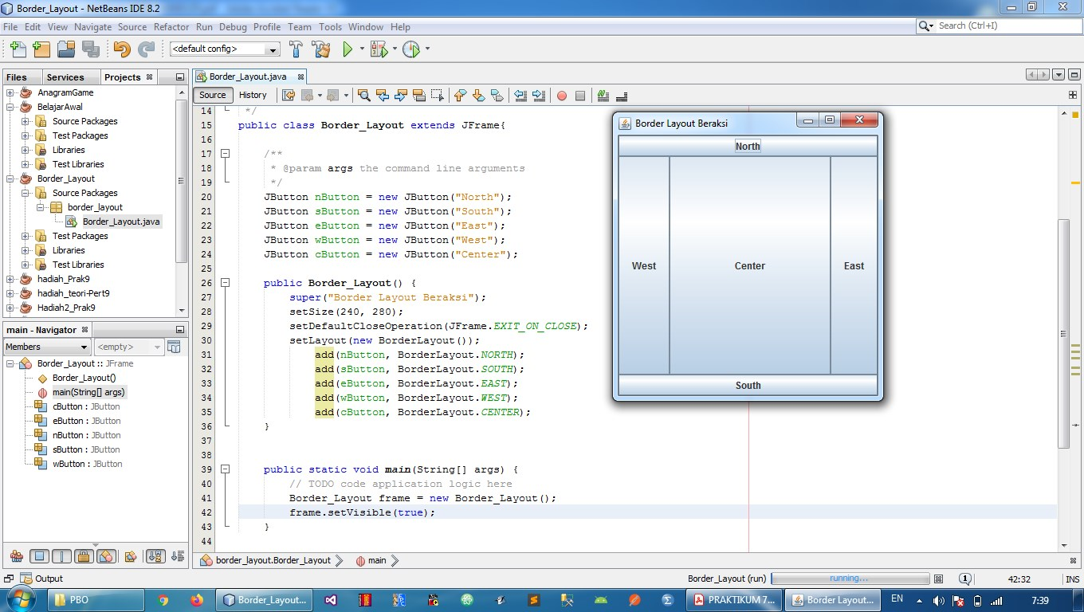

Latihan 2 FlowLayout
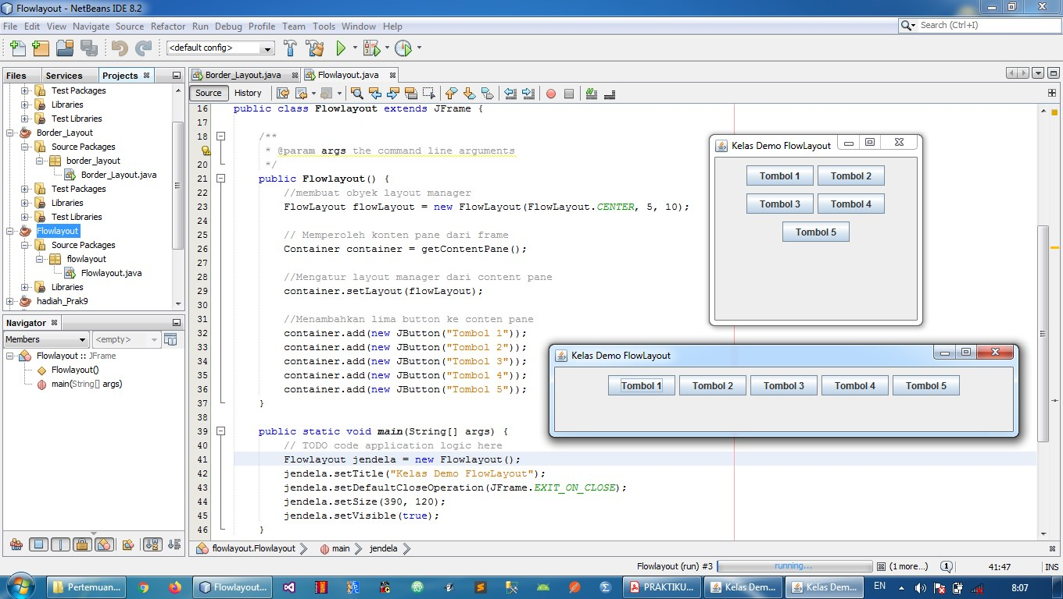
Latihan 3 GridLayout
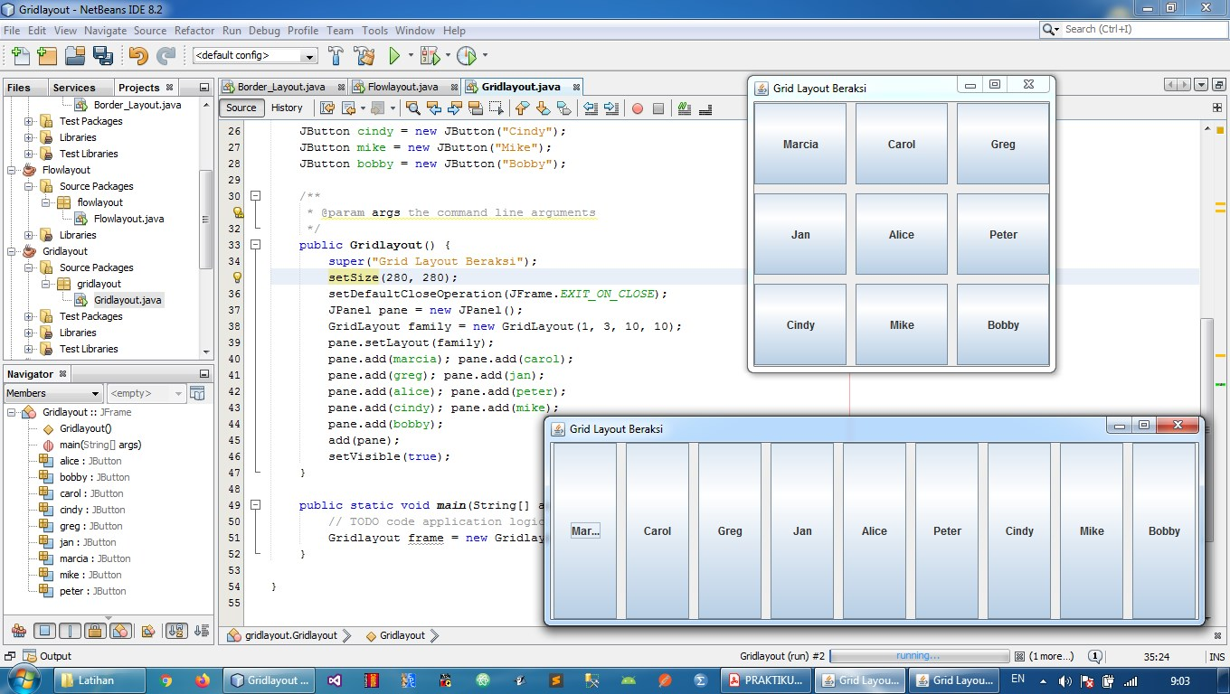

Latihan 4 GridBagLayout
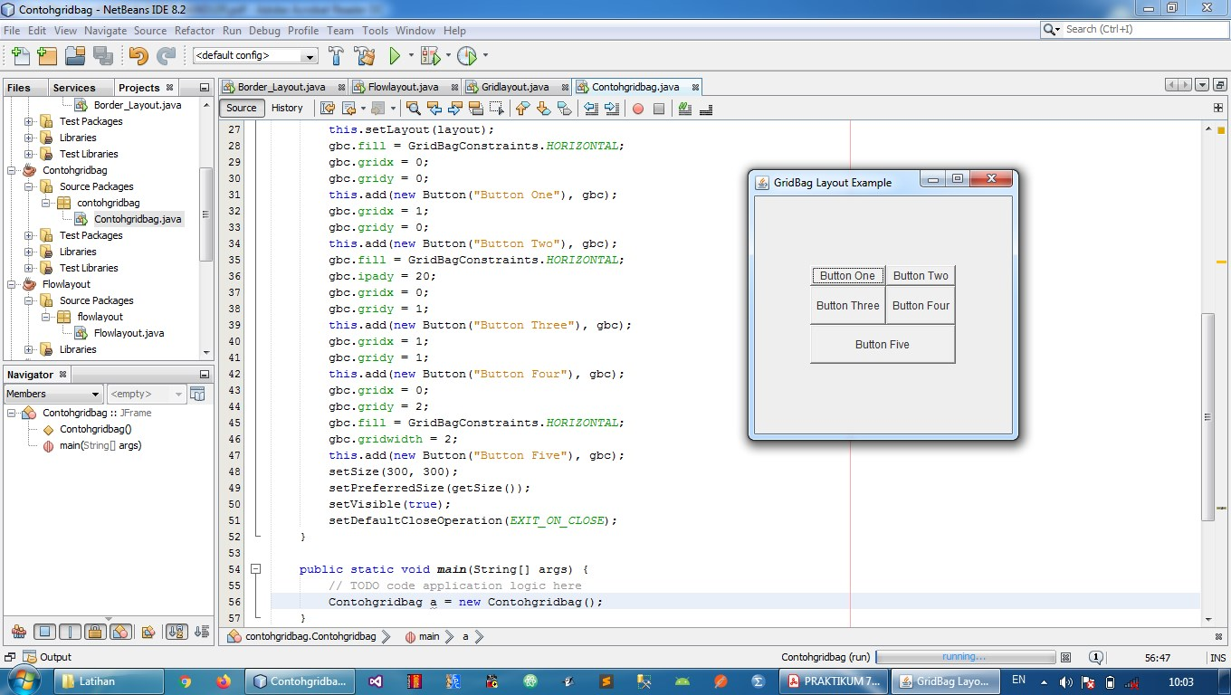

Latihan 5 Konversi Suhu CelciusToFahrenheit
